# Outreach Reporting Application

Outreach Reporting Application is a system that helps client to access the Volunteering report which has the below metrics. You want to build a data driven application and empower it with analytics. The whole integration process should run smoothly. The data should be more expressive and build a dashboard with aggregated data in combination with area/bar charts, histograms, etc.

• Participation Metrics

• Engagement Metrics

• Retention Metrics

• Acquisition Metrics

• General Metrics

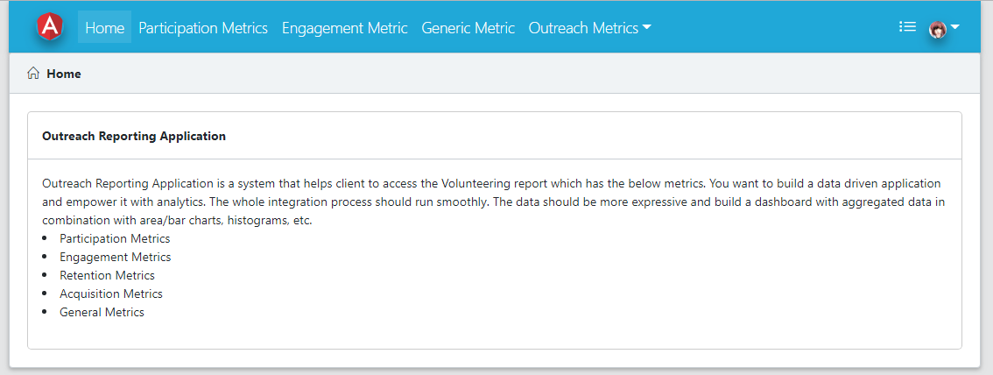

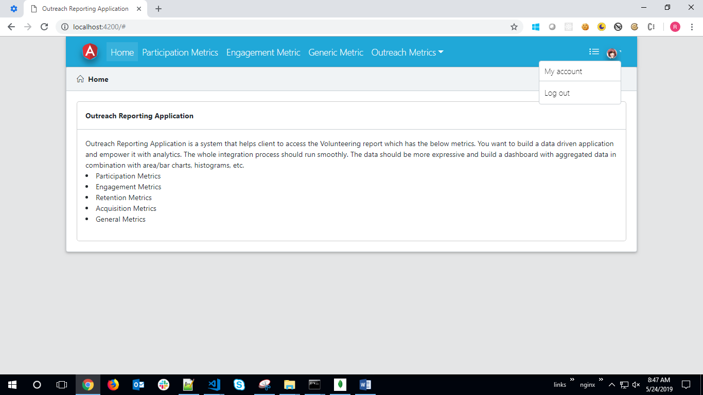

# Participation Metrics DashBoard

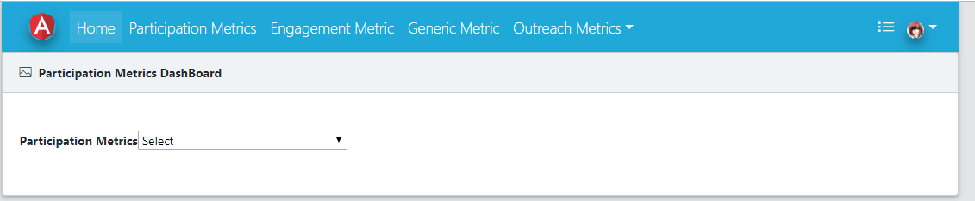

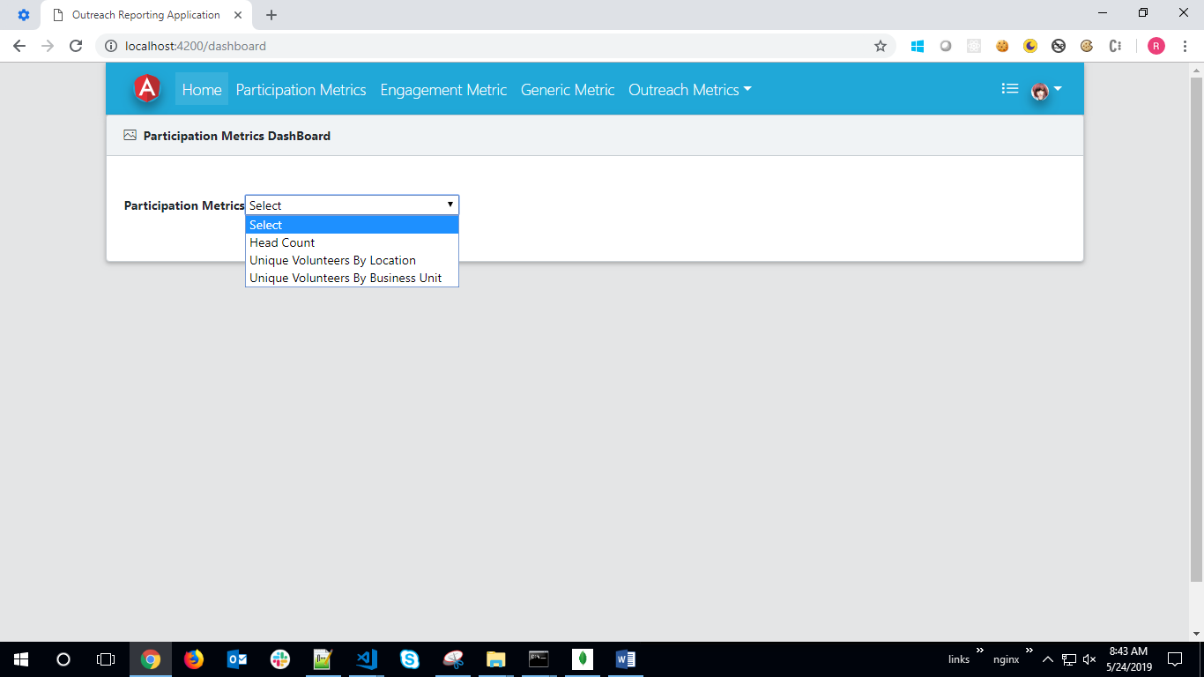

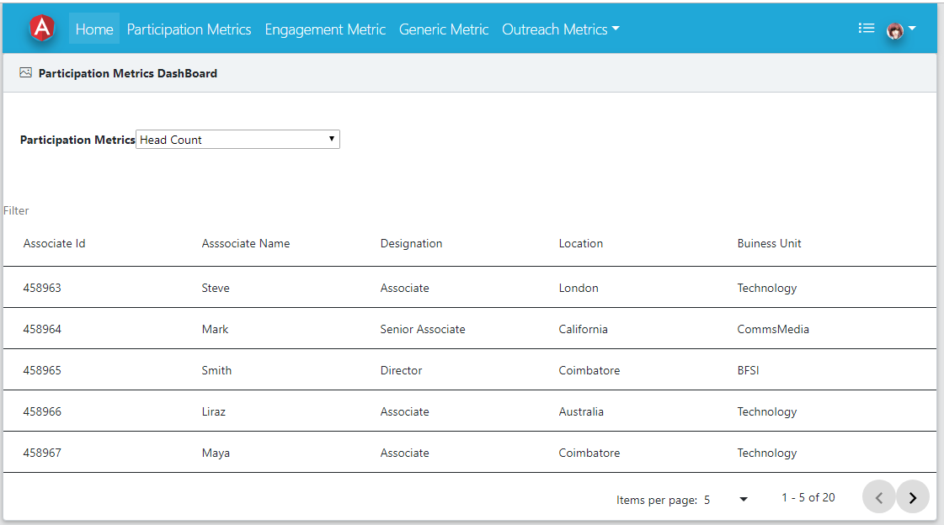

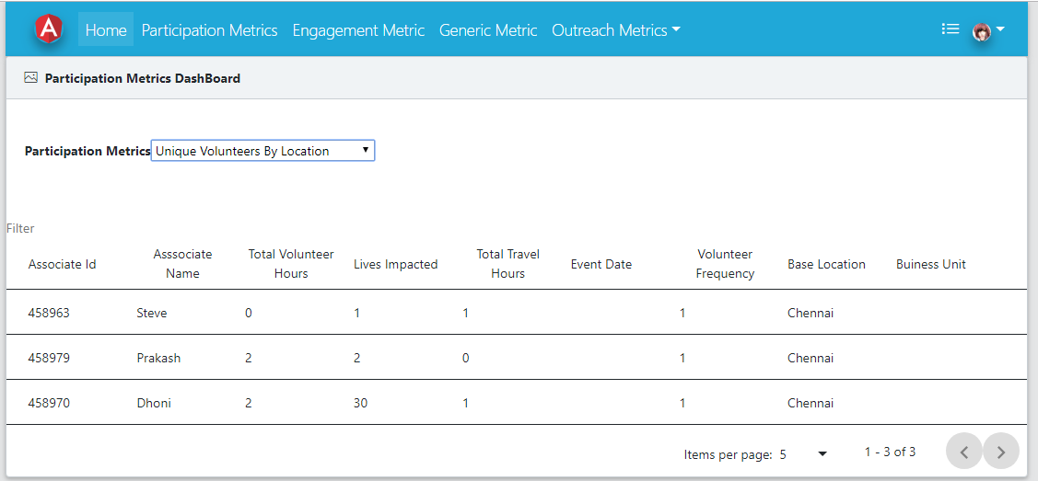

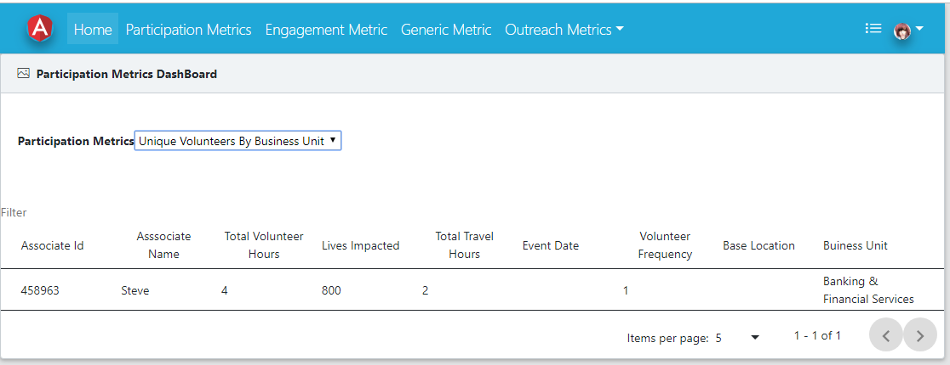

# Engagement Metrics DashBoard

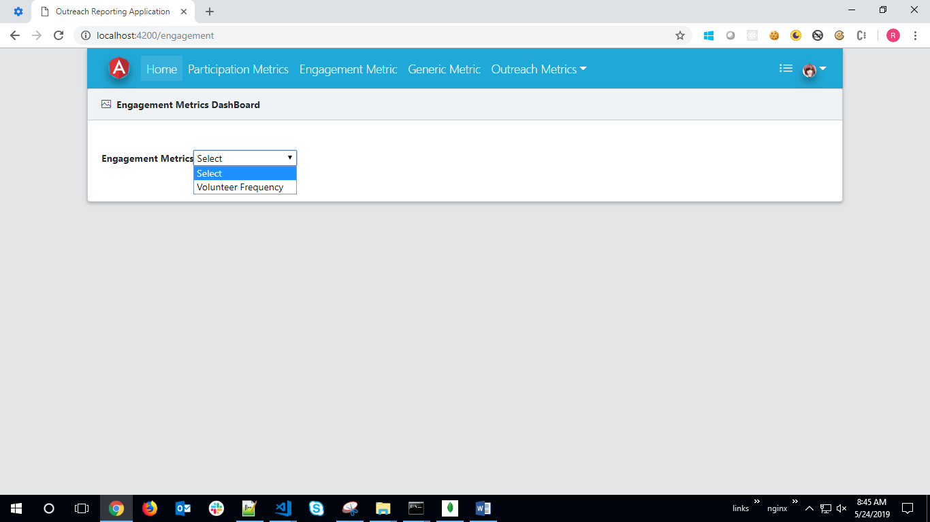

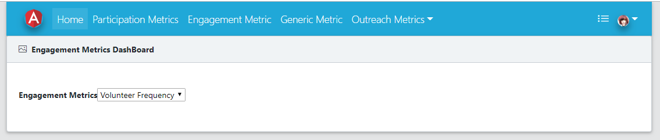

# Generic Metrics DashBoard

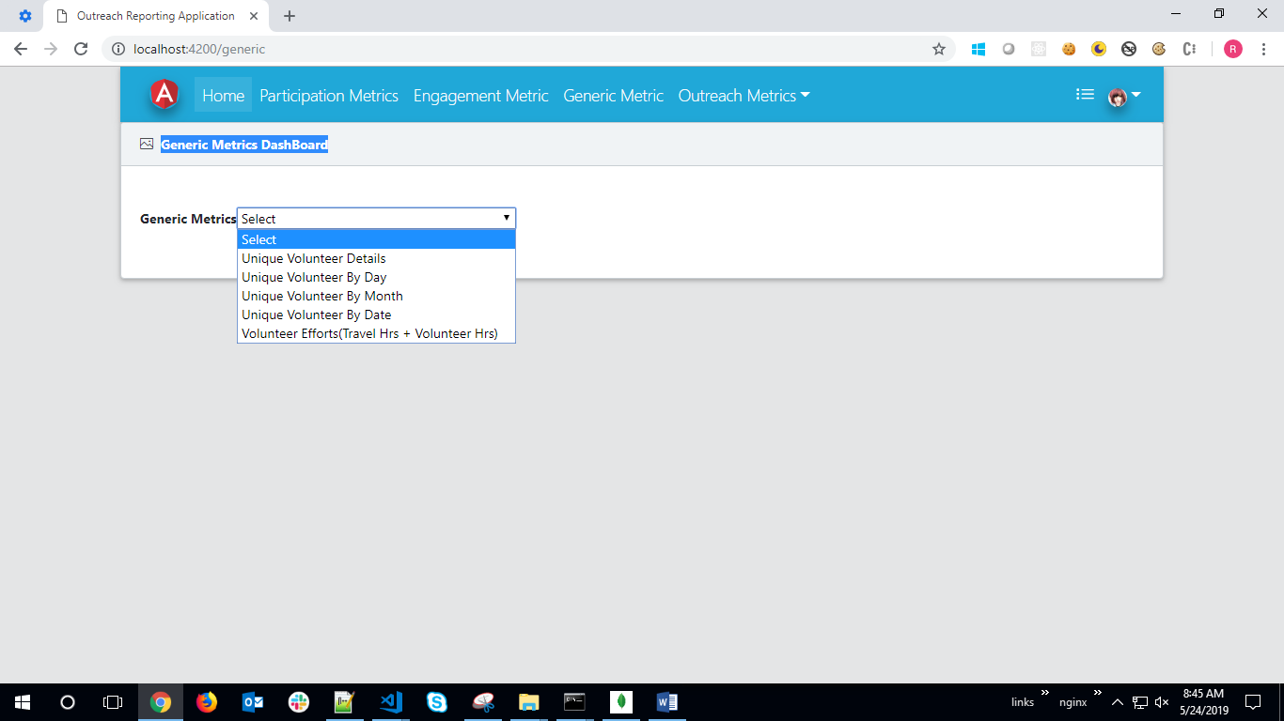

# Outreach Metrics

